**Date:** 23/02/22

**Exp 05 – FIRST and FOLLOW**

***Ayush Jindal***

***RA1911003010308***

***AIM:*** *Implementation of First and Follow*

***Code:***

*import sys*

*sys.setrecursionlimit(60)*

*def first(string):*

*first_ = set()*

*if string in non_terminals:*

*alternatives = productions_dict[string]*

*for alternative in alternatives:*

*first_2 = first(alternative)*

*first_ = first_ |first_2*

*elif string in terminals:*

*first_ = {string}*

*elif string=='' or string=='@':*

*first_ = {'@'}*

*else:*

*first_2 = first(string[0])*

*if '@' in first_2:*

*i = 1*

*while '@' in first_2:*

*first_ = first_ | (first_2 - {'@'})*

*if string[i:] in terminals:*

*first_ = first_ | {string[i:]}*

*break*

*elif string[i:] == '':*

*first_ = first_ | {'@'}*

*break*

*first_2 = first(string[i:])*

*first_ = first_ | first_2 - {'@'}*

*i += 1*

*else:*

*first_ = first_ | first_2*

*return first_*

*def follow(nT):*

*follow_ = set()*

*prods = productions_dict.items()*

*if nT==starting_symbol:*

*follow_ = follow_ | {'$'}*

*for nt,rhs in prods:*

*for alt in rhs:*

*for char in alt:*

*if char==nT:*

*following_str = alt[alt.index(char) + 1:]*

*if following_str=='':*

*if nt==nT:*

*continue*

*else:*

*follow_ = follow_ | follow(nt)*

*else:*

*follow_2 = first(following_str)*

*if '@' in follow_2:*

*follow_ = follow_ | follow_2-{'@'}*

*follow_ = follow_ | follow(nt)*

*else:*

*follow_ = follow_ | follow_2*

*return follow_*

*no_of_terminals=int(input("Enter no. of terminals: "))*

*terminals = []*

*print("Enter the terminals :")*

*for _ in range(no_of_terminals):*

*terminals.append(input())*

*no_of_non_terminals=int(input("Enter no. of non terminals: "))*

*non_terminals = []*

*print("Enter the non terminals :")*

*for _ in range(no_of_non_terminals):*

*non_terminals.append(input())*

*starting_symbol = input("Enter the starting symbol: ")*

*no_of_productions = int(input("Enter no of productions: "))*

*productions = []*

*print("Enter the productions:")*

*for _ in range(no_of_productions):*

*productions.append(input())*

*productions_dict = {}*

*for nT in non_terminals:*

*productions_dict[nT] = []*

*for production in productions:*

*nonterm_to_prod = production.split("->")*

*alternatives = nonterm_to_prod[1].split("/")*

*for alternative in alternatives:*

*productions_dict[nonterm_to_prod[0]].append(alternative)*

*FIRST = {}*

*FOLLOW = {}*

*for non_terminal in non_terminals:*

*FIRST[non_terminal] = set()*

*for non_terminal in non_terminals:*

*FOLLOW[non_terminal] = set()*

*for non_terminal in non_terminals:*

*FIRST[non_terminal] = FIRST[non_terminal] | first(non_terminal)*

*FOLLOW[starting_symbol] = FOLLOW[starting_symbol] | {'$'}*

*for non_terminal in non_terminals:*

*FOLLOW[non_terminal] = FOLLOW[non_terminal] | follow(non_terminal)*

*print("{: ^20}{: ^20}{: ^20}".format('Non Terminals','First','Follow'))*

*for non_terminal in non_terminals:*

*print("{: ^20}{: ^20}{: ^20}".format(non_terminal,str(FIRST[non_terminal]),str(FOLLOW[non_terminal])))*

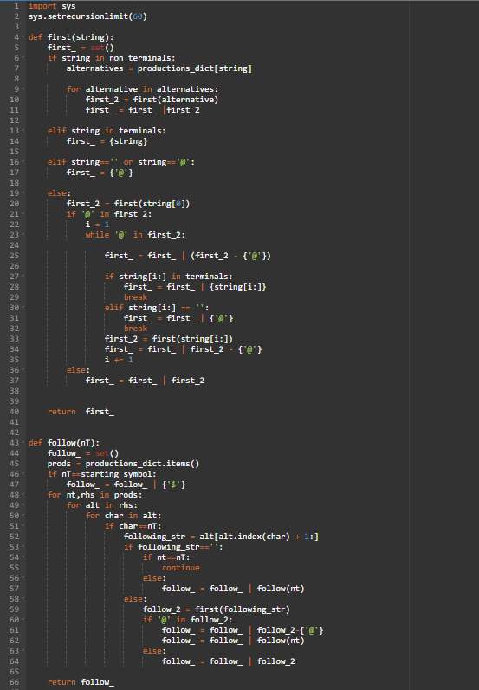

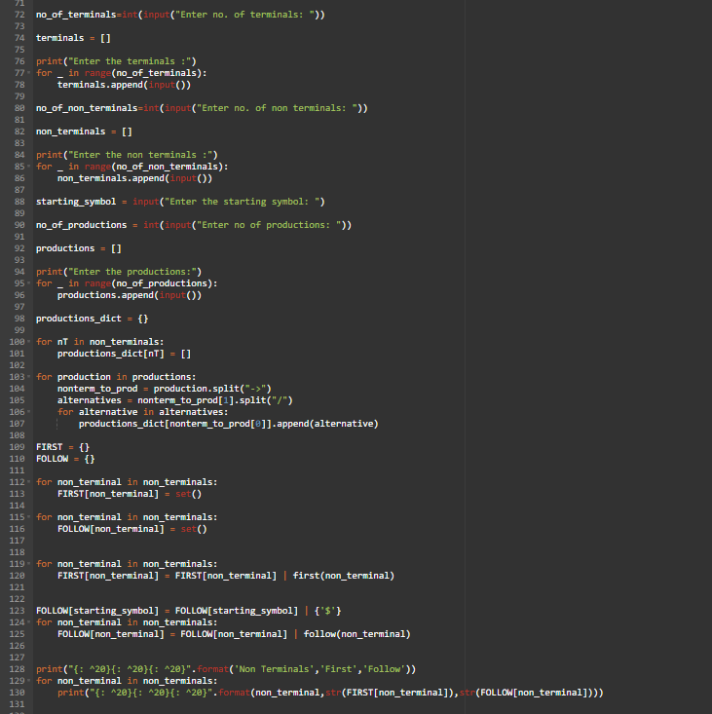

***Output:***

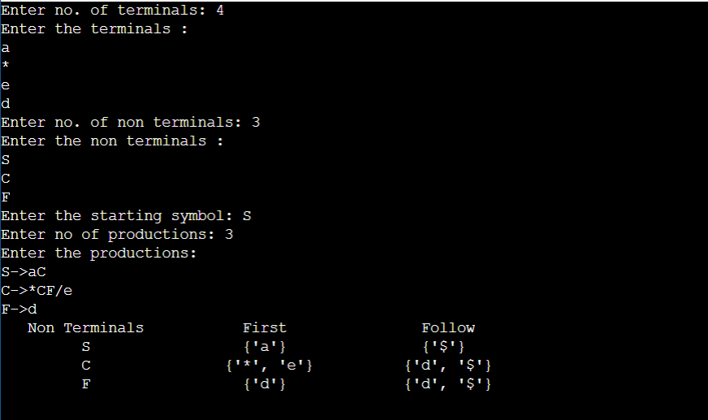

***Result:***

*The FIRST and FOLLOW of the grammar were found successfully.*